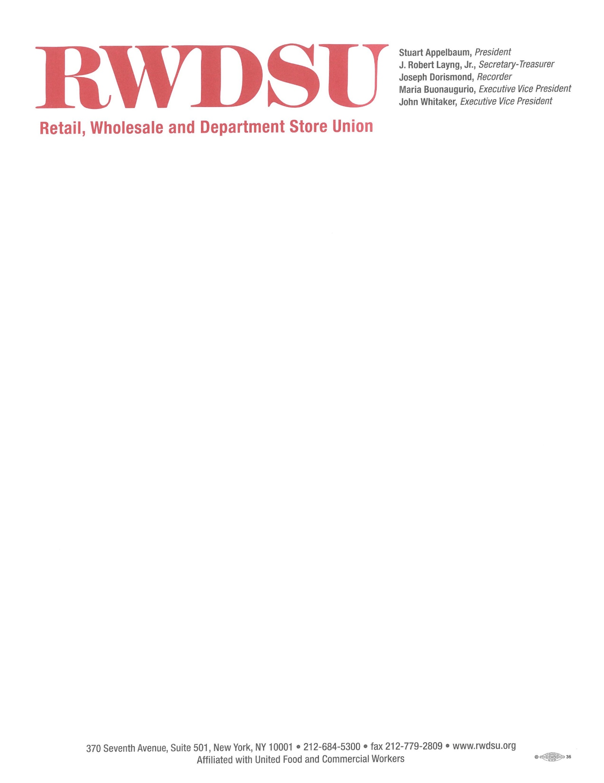

February 23, 2024

MEMORANDUM IN OPPOSITION

S.237B (May))/A.6353 (Glick): Expands the Bottle Bill to most beverages, increases the deposit to 10¢, and the handling fee to 6¢

The Retail, Wholesale, and Department Store Union (“RWDSU”) represents approximately 40,000 workers in New York. Our members work in retail, including apparel retail, grocery and pharmacies, food service, food processing, distribution, cannabis, building services, warehousing, carwashes and agriculture.

The RWDSU is strongly opposed to S. 237B/A.6353, which seeks to expand New York’s bottle redemption system. As the President of RWDSU, I have concerns that expanding this program without fixing its existing flaws will jeopardize jobs, put disproportionate financial burden on hardworking families, and not increase recycling rates.

New York’s bottle redemption system is set up for customers to collect their plastic and glass bottles and bring them to redemption centers for a deposit. But it has core defects: it‘s antiquated, it’s inconvenient for customers, and rife with fraud. New Yorkers are also not using it which has resulted in recent closings and union job losses at over 100 redemption centers last year.

Expanding the current broken system and hiking its fees without making important reforms first is a bad idea. This new bill would expand the bottle deposit law to include fruit and vegetable juices, coffee, tea, and a huge array of other drinks by 2026, resulting in doubling the deposit fees for cans and bottles on more items purchased by working families at the check-out-counter.

This bill will make life more difficult and expensive for workers, their families, and local businesses without fixing any of the issues that are plaguing the system. Under the new bill, a 24-pack of apple juice bottles would tack on another $1.80 in fees. That is on top of the $2.04 in fees that the state already levies on it. That sharp increase would be a dramatic blow to families and businesses in New York. These costs add up. By expanding a broken system without fixing the defects, the proposed bill would merely raise costs for local businesses and working families who are already coping with an excessive cost of living, including high grocery prices.

This expansion proposal will cost workers dearly. The increased fees will force small businesses to cut expenses and could lead to employees losing hours, or even their jobs. Many of the workers who will be affected are union workers.

There must be a better way, and we must work together to find it. If we really want a better recycling system that works for New Yorkers, let us not double down on what is not working but focus on creating a system that works. Let us protect workers, consumers, our small local businesses, and the environment by reforming our bottle redemption system into a more affordable, efficient, and effective program that will position New York as a leader on this issue.

Sincerely,

Stuart Appelbaum
President

